Atlantix is a premier finance, accounting, and technology solutions provider to public and private companies. Working at the intersection of business and technology, our professionals help companies increase reporting efficiencies, find their edge, boost performance, and drive verifiable deltas in enterprise value.
Founded over 20 years ago, we attribute our success to staying ahead of emerging trends by finding tech-enabled solutions to alleviate the challenges of thirty-year-old spreadsheets. We provide current solutions to keeping up with today’s fast paced information exchange, leaving many in a data paradox.
Our internally developed EdgeVuTM platform turns data struggles into a powerful information edge, enabled with speed and accuracy, easing resource dependency.
Atlantix and Marshall & Stevens work together to provide an integrated solution to transaction preparation, execution, and reporting.
SERVING
Private Equity
Public Companies

CONSULTING SERVICES
Financial Planning & Analysis
Interim Staffing Services
Digital Services & Data Analytics
Information Technology
Technical Accounting and Support
Process Improvement

DIGITAL SOLUTIONS
Overview
EdgeVu™ One
EdgeVu™ Advantage
News
CORPORATE HEADQUARTERS
800 Corporate Drive, Suite 408
Ft. Lauderdale, Florida 33334

T: 954.734.2360
F: 954.734.2909

atlantixpartners.com

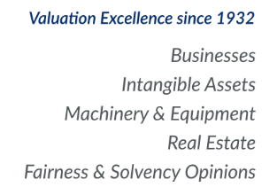

Marshall & Stevens provides independent opinions of value to public and private companies, debt and equity investors, and independent directors. The majority of our clients are referred to us by audit, tax, legal, wealth management, and transaction advisors.
Valuation services by category include:
- Fairness Opinion
- Solvency Opinion
- Financial Reporting
- Tax Valuations
- Bankruptcy & Restructuring
- Dispute & Litigation Support
- Investment Banking
- Financial Valuation
- Machinery & Equipment
- Real Estate Valuation
- Energy & Infrastructure
- Healthcare
- SPACs

Atlantix and Marshall & Stevens work together to provide an integrated solution to transaction preparation, execution, and reporting.
WHO WE SERVE Corporate Headquarters
Business Owners 800 West Sixth St., Suite 950
Company Management Los Angeles, CA 90017
Equity and Debt Investors 213-300-2682
Transaction Advisors marshall-stevens.com

